**Spring Boot – Feedback**

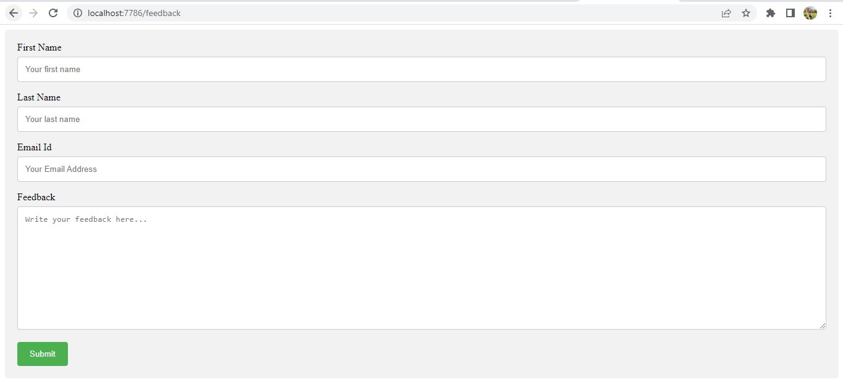

* This is the user interface.
* Fields in this UI are first name, last name, email id and feedback
* Receiving feedback is the main purpose of this application.
* Then submit button is clicked once the details are entered.

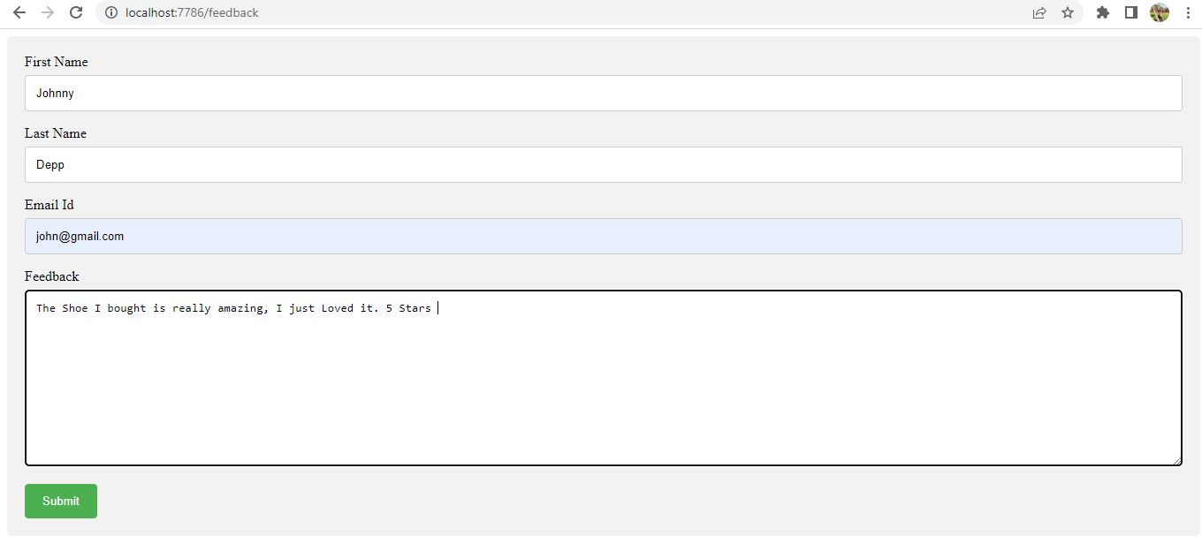

* Details for first name, second name, email id and feedbacks are entered
* After entering the details clicked on submit

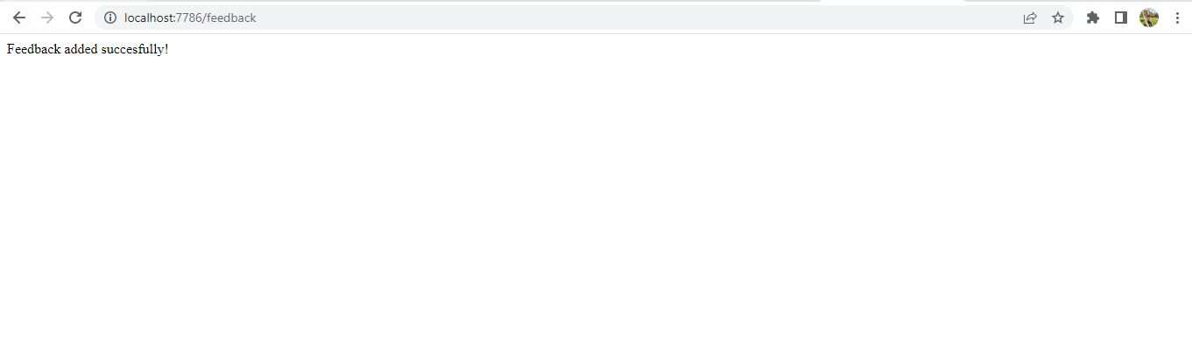

* When details are submitted, and there is no error , then Feedback added successfully message will be displayed.

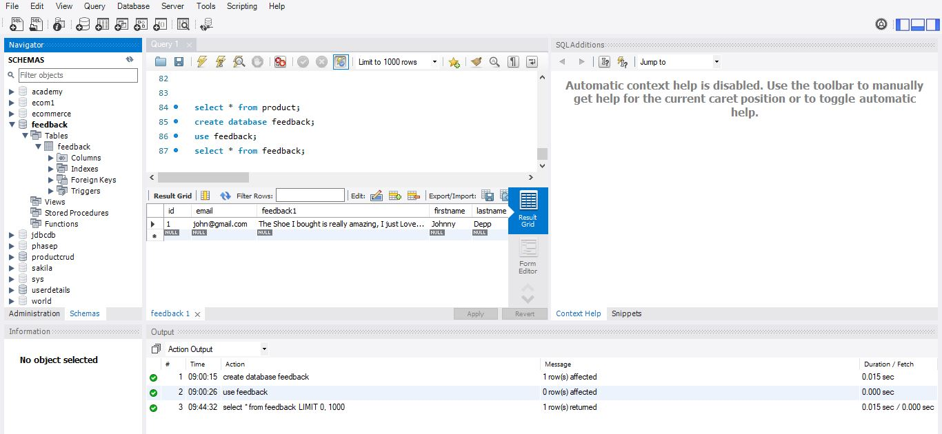

* The data entered is reflected in the mysql database.